**Name: Dhanraj Subhash Kore**

**Div : B Roll No: 60**

**Batch: B-3**

**Sub : CS LAB Assignment**

**LAB 2 Implementation of Data Encryption Standard (DES) Algorithm**

**Output screen:**

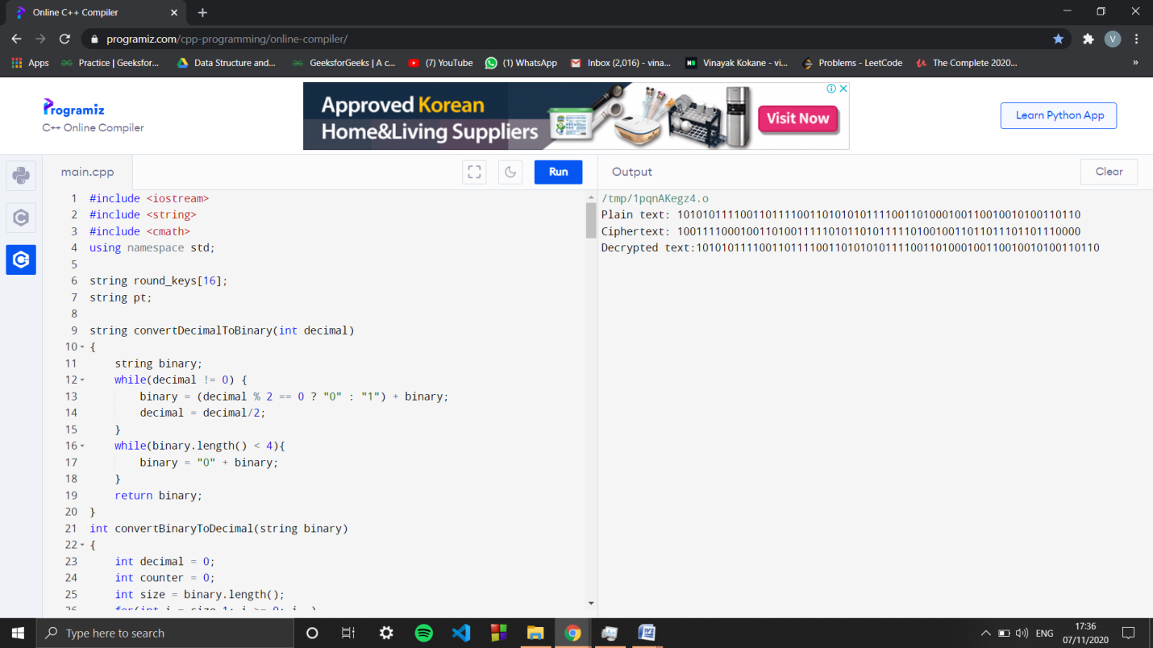

**Code**

#include <iostream>

#include <string>

#include <cmath>

using namespace std;

string round_keys[16];

string pt;

string convertDecimalToBinary(int decimal)

{

string binary;

while(decimal != 0) {

binary = (decimal % 2 == 0 ? "0" : "1") + binary;

decimal = decimal/2;

}

while(binary.length() < 4){

binary = "0" + binary;

}

return binary;

}

int convertBinaryToDecimal(string binary)

{

int decimal = 0;

int counter = 0;

int size = binary.length();

for(int i = size-1; i >= 0; i--)

{

if(binary[i] == '1'){

decimal += pow(2, counter);

}

counter++;

}

return decimal;

}

// Function to do a circular left shift by 1

string shift_left_once(string key_chunk){

string shifted="";

for(int i = 1; i < 28; i++){

shifted += key_chunk[i];

}

shifted += key_chunk[0];

return shifted;

}

string shift_left_twice(string key_chunk){

string shifted="";

for(int i = 0; i < 2; i++){

for(int j = 1; j < 28; j++){

shifted += key_chunk[j];

}

shifted += key_chunk[0];

key_chunk= shifted;

shifted ="";

}

return key_chunk;

}

// Function to compute xor between two strings

string Xor(string a, string b){

string result = "";

int size = b.size();

for(int i = 0; i < size; i++){

if(a[i] != b[i]){

result += "1";

}

else{

result += "0";

}

}

return result;

}

// Function to generate the 16 keys.

void generate_keys(string key){

// The PC1 table

int pc1[56] = {

57,49,41,33,25,17,9,

1,58,50,42,34,26,18,

10,2,59,51,43,35,27,

19,11,3,60,52,44,36,

63,55,47,39,31,23,15,

7,62,54,46,38,30,22,

14,6,61,53,45,37,29,

21,13,5,28,20,12,4

};

// The PC2 table

int pc2[48] = {

14,17,11,24,1,5,

3,28,15,6,21,10,

23,19,12,4,26,8,

16,7,27,20,13,2,

41,52,31,37,47,55,

30,40,51,45,33,48,

44,49,39,56,34,53,

46,42,50,36,29,32

};

// 1. Compressing the key using the PC1 table

string perm_key ="";

for(int i = 0; i < 56; i++){

perm_key+= key[pc1[i]-1];

}

// 2. Dividing the key into two equal halves

string left= perm_key.substr(0, 28);

string right= perm_key.substr(28, 28);

for(int i=0; i<16; i++){

// 3.1. For rounds 1, 2, 9, 16 the key_chunks

// are shifted by one.

if(i == 0 || i == 1 || i==8 || i==15 ){

left= shift_left_once(left);

right= shift_left_once(right);

}

else{

left= shift_left_twice(left);

right= shift_left_twice(right);

}

string combined_key = left + right;

string round_key = "";

for(int i = 0; i < 48; i++){

round_key += combined_key[pc2[i]-1];

}

round_keys[i] = round_key;

}

}

string DES(){

int initial_permutation[64] = {

58,50,42,34,26,18,10,2,

60,52,44,36,28,20,12,4,

62,54,46,38,30,22,14,6,

64,56,48,40,32,24,16,8,

57,49,41,33,25,17,9,1,

59,51,43,35,27,19,11,3,

61,53,45,37,29,21,13,5,

63,55,47,39,31,23,15,7

};

int expansion_table[48] = {

32,1,2,3,4,5,4,5,

6,7,8,9,8,9,10,11,

12,13,12,13,14,15,16,17,

16,17,18,19,20,21,20,21,

22,23,24,25,24,25,26,27,

28,29,28,29,30,31,32,1

};

int substition_boxes[8][4][16]=

{{

14,4,13,1,2,15,11,8,3,10,6,12,5,9,0,7,

0,15,7,4,14,2,13,1,10,6,12,11,9,5,3,8,

4,1,14,8,13,6,2,11,15,12,9,7,3,10,5,0,

15,12,8,2,4,9,1,7,5,11,3,14,10,0,6,13

},

{

15,1,8,14,6,11,3,4,9,7,2,13,12,0,5,10,

3,13,4,7,15,2,8,14,12,0,1,10,6,9,11,5,

0,14,7,11,10,4,13,1,5,8,12,6,9,3,2,15,

13,8,10,1,3,15,4,2,11,6,7,12,0,5,14,9

},

{

10,0,9,14,6,3,15,5,1,13,12,7,11,4,2,8,

13,7,0,9,3,4,6,10,2,8,5,14,12,11,15,1,

13,6,4,9,8,15,3,0,11,1,2,12,5,10,14,7,

1,10,13,0,6,9,8,7,4,15,14,3,11,5,2,12

},

{

7,13,14,3,0,6,9,10,1,2,8,5,11,12,4,15,

13,8,11,5,6,15,0,3,4,7,2,12,1,10,14,9,

10,6,9,0,12,11,7,13,15,1,3,14,5,2,8,4,

3,15,0,6,10,1,13,8,9,4,5,11,12,7,2,14

},

{

2,12,4,1,7,10,11,6,8,5,3,15,13,0,14,9,

14,11,2,12,4,7,13,1,5,0,15,10,3,9,8,6,

4,2,1,11,10,13,7,8,15,9,12,5,6,3,0,14,

11,8,12,7,1,14,2,13,6,15,0,9,10,4,5,3

},

{

12,1,10,15,9,2,6,8,0,13,3,4,14,7,5,11,

10,15,4,2,7,12,9,5,6,1,13,14,0,11,3,8,

9,14,15,5,2,8,12,3,7,0,4,10,1,13,11,6,

4,3,2,12,9,5,15,10,11,14,1,7,6,0,8,13

},

{

4,11,2,14,15,0,8,13,3,12,9,7,5,10,6,1,

13,0,11,7,4,9,1,10,14,3,5,12,2,15,8,6,

1,4,11,13,12,3,7,14,10,15,6,8,0,5,9,2,

6,11,13,8,1,4,10,7,9,5,0,15,14,2,3,12

},

{

13,2,8,4,6,15,11,1,10,9,3,14,5,0,12,7,

1,15,13,8,10,3,7,4,12,5,6,11,0,14,9,2,

7,11,4,1,9,12,14,2,0,6,10,13,15,3,5,8,

2,1,14,7,4,10,8,13,15,12,9,0,3,5,6,11

}};

int permutation_tab[32] = {

16,7,20,21,29,12,28,17,

1,15,23,26,5,18,31,10,

2,8,24,14,32,27,3,9,

19,13,30,6,22,11,4,25

};

int inverse_permutation[64]= {

40,8,48,16,56,24,64,32,

39,7,47,15,55,23,63,31,

38,6,46,14,54,22,62,30,

37,5,45,13,53,21,61,29,

36,4,44,12,52,20,60,28,

35,3,43,11,51,19,59,27,

34,2,42,10,50,18,58,26,

33,1,41,9,49,17,57,25

};

string perm = "";

for(int i = 0; i < 64; i++){

perm += pt[initial_permutation[i]-1];

}

string left = perm.substr(0, 32);

string right = perm.substr(32, 32);

for(int i=0; i<16; i++) {

string right_expanded = "";

for(int i = 0; i < 48; i++) {

right_expanded += right[expansion_table[i]-1];

};

string xored = Xor(round_keys[i], right_expanded);

string res = "";

for(int i=0;i<8; i++){

string row1= xored.substr(i*6,1) + xored.substr(i*6 + 5,1);

int row = convertBinaryToDecimal(row1);

string col1 = xored.substr(i*6 + 1,1) + xored.substr(i*6 + 2,1) + xored.substr(i*6 + 3,1) + xored.substr(i*6 + 4,1);;

int col = convertBinaryToDecimal(col1);

int val = substition_boxes[i][row][col];

res += convertDecimalToBinary(val);

}

string perm2 ="";

for(int i = 0; i < 32; i++){

perm2 += res[permutation_tab[i]-1];

}

xored = Xor(perm2, left);

left = xored;

if(i < 15){

string temp = right;

right = xored;

left = temp;

}

}

string combined_text = left + right;

string ciphertext ="";

for(int i = 0; i < 64; i++){

ciphertext+= combined_text[inverse_permutation[i]-1];

}

return ciphertext;

}

int main(){

string key= "1010101010111011000010010001100000100111001101101100110011011101";

pt= "1010101111001101111001101010101111001101000100110010010100110110";

string apt = pt;

generate_keys(key);

cout<<"Plain text: "<<pt<<endl;

string ct= DES();

cout<<"Ciphertext: "<<ct<<endl;

int i = 15;

int j = 0;

while(i > j)

{

string temp = round_keys[i];

round_keys[i] = round_keys[j];

round_keys[j] = temp;

i--;

j++;

}

pt = ct;

string decrypted = DES();

cout<<"Decrypted text:"<<decrypted<<endl;

}